Most candidates:
Apply → wait → lose confidence → repeat
But hiring actually works like this:
Recruiters search database → shortlist → THEN post job
Meaning:
If you only apply, you are already late.
So you must try this together 👇
🔹️ Apply only to fresh jobs (posted within 24 hours)
Main Platforms:
LinkedIn Jobs — https://lnkd.in/dfA5RhbR
Indeed — https://in.indeed.com
Naukri — https://www.naukri.com
Foundit — https://www.foundit.in
Glassdoor —https://lnkd.in/dDEjxM8z
Rules:
• 10–15 targeted applications/day
• No mass applying
• Resume must match role keywords
Example:
12 relevant applications > 80 random applications
🔹️ After applying → message recruiter same day
Message template:
Hi [Name], I applied for the [Role] position.
I recently worked on a project solving [problem].
Would love to know what skills your team prioritizes.
Follow-up after 3 days:
Just checking if the role is active — happy to share my portfolio.
This increases replies drastically.
🔹️ Less competition platforms (very powerful):
Wellfound — https://wellfound.com/jobs
CutShort — https://cutshort.io
Instahyre — https://www.instahyre.com
Hirist — https://www.hirist.com
Hasjob — https://hasjob.co
YCombinator Jobs —https://lnkd.in/dAkRFzTK
Recruiters directly search profiles here.
🔹️ GLOBAL / REMOTE JOBS (Break location barrier)
• RemoteOK — https://remoteok.com
• WeWorkRemotely —https://weworkremotely.com
• Remotive — https://remotive.com
• Turing — https://www.turing.com
• Deel — https://lnkd.in/dArinjkG
Best time to apply: 7 PM – 10 PM IST
🔹️ NETWORKING ENGINE (Real job source)
Daily 30 min routine:
• Comment on 5 hiring posts
• Connect with 10 recruiters
• Connect with 5 employees of target companies
Because:
Conversations → referrals → interviews → jobs
Not resumes.
🔹️ TRACK YOUR APPLICATIONS (Mandatory)
Create a tracker:
Company | Role | Date | Recruiter | Follow-up | Status
No tracking = burnout
Tracking = predictable progress
🔹️ WEEKLY ROUTINE
Mon–Fri → apply + connect
Saturday → projects & mock interviews
Sunday → networking only
Job search is not luck.
It is a lead-generation funnel.
- Applications = leads
- Conversations = prospects
- Interviews = conversions
Follow this for 21 days consistently,
you WILL start getting replies.
This is only the framework.
♻️ Follow for more such insights on Data + AI
- https://lnkd.in/dgPk_6Rv
- https://t.me/dswm7
- https://lnkd.in/gEmwTM3s
Activate to view larger image,
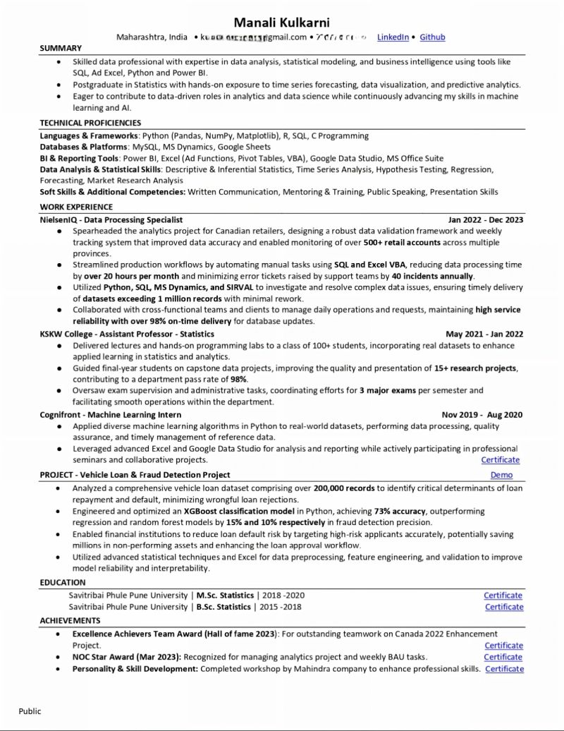

𝗝𝗼𝗶𝗻 𝗺𝘆 𝗰𝗼𝗺𝗺𝘂𝗻𝗶𝘁𝘆 𝗵𝗲𝗿𝗲:
→ WhatsApp - https://lnkd.in/dgPk_6Rv
→ Telegram - https://t.me/dswm7
→ Topmate - https://topmate.io/manali_kulkarni/

Ever wondered why less skilled people get shortlisted over you?
Here’s how to write a resume that makes them say “We NEED this person!”
𝟭. 𝗡𝗼 𝗼𝗻𝗲 𝗿𝗲𝗮𝗱𝘀 𝘆𝗼𝘂𝗿 𝗼𝗯𝗷𝗲𝗰𝘁𝗶𝘃𝗲.
That 2-line generic “seeking a challenging role…” stuff? Delete it.
Instead, say what you want + what you bring.
“Looking for a Data Analyst role where I can turn messy data into meaningful business stories using SQL, Excel, and Power BI.”
Now that’s solid.
𝟮. 𝗬𝗼𝘂𝗿 𝗲𝗱𝘂𝗰𝗮𝘁𝗶𝗼𝗻 𝘀𝗲𝗰𝘁𝗶𝗼𝗻 𝗶𝘀𝗻’𝘁 𝗮 𝗳𝗼𝗿𝗺𝗮𝗹𝗶𝘁𝘆.
Add what actually matters ⋙ tools you learned, case studies, hands-on stuff, even a cool project you cracked. Show that you’ve applied what you learned.
𝟯. 𝗗𝗼𝗻’𝘁 𝗹𝗶𝘀𝘁 𝘆𝗼𝘂𝗿 𝗷𝗼𝗯 𝗱𝘂𝘁𝗶𝗲𝘀. 𝗦𝗵𝗼𝘄 𝘆𝗼𝘂𝗿 𝘄𝗶𝗻𝘀.
“Did data cleaning.”
Nope.
“Cleaned 50k+ rows using Python, improved reporting accuracy by 30%.”
Now we’re talking.
𝟰. 𝗦𝘁𝗼𝗽 𝘂𝘀𝗶𝗻𝗴 𝘁𝗵𝗲 𝘀𝗮𝗺𝗲 𝗿𝗲𝘀𝘂𝗺𝗲 𝗳𝗼𝗿 𝗲𝘃𝗲𝗿𝘆 𝗷𝗼𝗯.
Tailor it. Match your skills to the job post.
If they’re asking for Excel dashboards, and yours are missing?
You’re out. Simple.
𝟱. 𝗧𝗵𝗶𝗻𝗸 𝗹𝗶𝗸𝗲 𝗮 𝗺𝗮𝗿𝗸𝗲𝘁𝗲𝗿. 𝗡𝗼𝘁 𝗮 𝗻𝗮𝗿𝗿𝗮𝘁𝗼𝗿.
Your resume should SELL you, not tell your life story.
Give proof, show energy, and keep it clean (no grammar or layout disasters!).
I'm sharing the exact PDF to craft job-winning resumes.
Follow along if you want real preparation 👇
- https://lnkd.in/dgPk_6Rv
- https://t.me/dswm7
- https://lnkd.in/gEmwTM3s
🔄 Like & Repost to help others stay ahead!

I told my friend's sister:
"Send your resume to Claude before you send it anywhere else."
She laughed.
She tried it anyway.
8 interviews in 5 days.
Same experience.
Same skills.
Claude just helped her present them better.
These 5 prompts cover the entire job search journey:
📄 Resume → 🎯 Job Match → ✍️ Cover Letter → 💼 LinkedIn → 🎤 Interview
Here are the exact prompts she used 👇
Prompt 1 — Resume Optimizer
Paste your current resume and ask:
"You are a senior recruiter in [industry]. Rewrite this resume to pass ATS filters, use strong action verbs, and quantify achievements where possible. Keep it truthful to my actual experience."
Claude doesn't invent experience.
It helps highlight the impact you've already made.
Prompt 2 — Job Match Optimizer
"Here is the job description: [paste JD]. Here is my resume: [paste resume]. Rewrite my bullet points to mirror the language and keywords in this job description without lying."
Many resumes get overlooked because they don't match the language recruiters are searching for.
Prompt 3 — Cover Letter Generator
"Write a concise cover letter for this role using my resume. Tone: confident but not arrogant. Mention exactly one specific achievement that maps to the job requirements. Max 250 words."
Prompt 4 — LinkedIn Profile Optimizer
"Convert my resume into a LinkedIn About section and Headline. Focus on outcomes, not responsibilities. Include relevant keywords for [job title] roles."
Prompt 5 — Interview Coach
"I have an interview for this role. Based on my resume and the job description, ask me the 10 most likely interview questions and help me improve my answers."
AI didn't give her new experience.
It helped communicate her existing experience more effectively.
Stop saving AI threads you'll never use.
Start using them.
📌 Save this post for your next job application.
💬 Which prompt are you trying first?
♻️ Repost to help someone land their next opportunity.
🚀
Follow Harish Kumar for practical AI prompts and career tips.
Activate to view larger image,
